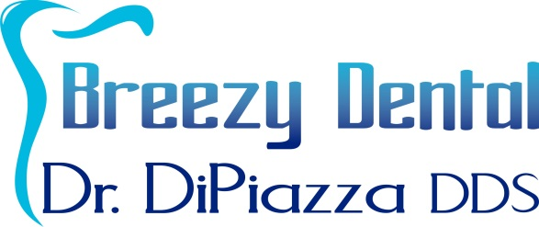
Notice of Privacy Practices Acknowledgement
and
Medical Record Release
Notice of Privacy Practices Acknowledgement
I understand that, under the Health Insurance Portability & Accountability Act of 1966 (“HIPPA”), I have certain rights to privacy regarding my protected health information. I understand that this information can and will be used to:
- Conduct plan and direct my treatment and follow-up among the multiple healthcare providers who may be involved in that treatment directly and indirectly.
- Obtain payment from third-party payers.
- Conduct normal healthcare operations such as quality assessments and physical certifications.
I have received, read and understand your Notice of Privacy Practices containing a more complete description of the uses and disclosures of my health information. I understand that this organization has the right to change its Notice of Privacy Practices from time to time and that I may contact this organization at any time at the address at the bottom of the page to obtain a current copy of the Notice of Privacy Practices.

I understand that I may request in writing that you restrict how my private information is used or disclosed to carry out treatment, payment, or health care operations. I also understand that you are not required to agree to my requested restrictions, but if you do agree, then you are bound to abide by those restrictions.

Patient Name: _____________________________________ Relationship to Patient_____________________________

Signature: _________________________________________ Date: _________________

Medical Record Release Form – Authorization to Disclose Health Information
I authorize the following individuals or organization to disclose my health information:
Breezy Dental, Dr. Michael DiPiazza DDS, and Staff

This information may be disclosed to and used by the following individual(s) or organization:

Name: ____________________________________________ Relationship: ___________________________________

I understand that the information in my health record may include information relating to sexually transmitted disease, acquired immunodeficiency syndrome (AIDS), or human immunodeficiency virus (HIV). It may also include information about behavioral or mental health services, and treatment for alcohol and drug abuse. I understand that I have a right to revoke this authorization at any time. I understand that if I revoke this authorization I must do so in writing and present my written revocation to the individual or organization releasing information. I understand that the revocation will not apply to my insurance company when the law provides my insurer with the right to contest a claim under my policy. Unless otherwise revoked, this authorization will expire on the following date, event, or condition: ______________________

If I fail to specify an expiration date, event, or condition, this authorization will expire in one year. I understand that authorizing the disclosure of this health information is voluntary. I can refuse to sign this authorization. I need not sign this form in order to ensure treatment. I understand that I may inspect or copy the information to be used or disclosed. I understand that any disclosure of information carries with it the potential for an unauthorized re-disclosure ant the information may not be protected by federal confidentiality rules.
If I have questions I can contact the office at 727-725-3279.

Patient Signature: __________________________________________________________________ Date: ____________________
Breezy Dental
Dr. Michael DiPiazza DDS
2519 N. McMullen Booth Rd, Suite 201
Clearwater, FL 33761
Ph: 727-725-3279 / Fax: 727-726-8905

