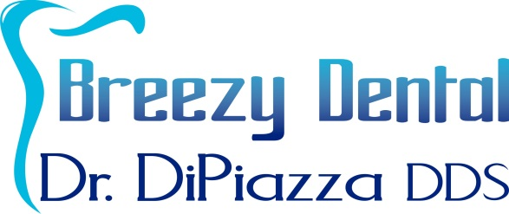
HMO Insurance Explanation and Policies

If you received this document, you have an HMO or DMO dental insurance. There are several differences between HMOs and traditional PPO (Preferred Provider Organization) insurance.
The Significant Differences between HMOs and Other Insurance:
- Exams, X-rays, and Cleanings are NOT free. They are paid by your insurance over time as you are assigned as a patient to this office.
- HMOs do not cover the services outside of diagnostic and preventive care. That means unlike traditional insurance which may pay for a percentage of fillings, crowns, periodontal treatments, etc, nothing is covered by HMOs. You pay out of pocket for all expenses.
- HMOs do not have inclusive billing. Many minor fees (tasks like office visits, sterilization, gingivectomy for restorative purposes) are incorporated into the larger fees on traditional insurance. The bills for HMOs are lengthy due to the breakdown of these minor fees. In the end, you actually pay more for HMO fees than PPO fees.

Our expectations of you as the HMO policy owner:
- You must call and be assigned as a patient to this office to receive services.
- You can be assigned by calling the number on your HMO card.
- Our facility number is 102366.
- If you do not get assigned to this office in 30 days, we will consider a theft of service has occurred. You will be charged as if you had no insurance.
- If you wish help in calling your HMO and getting assigned, please ask the front desk and they will provide a phone and assistance.
- If fees are not paid in 60 days, you will be sent to collections and your credit will be affected.
- Keeping our office informed of any changes in your insurance coverage or pertinent information relevant to your account with us.

Please be informed that our office holds a broken appointment policy and reserves the right to charge a $35 fee for each missed appointment. We require at least 24 hours notice to cancel or change an appointment.

I understand the policy concerning my HMO insurance as set forth to me by Breezy Dental and Dr. Michael DiPiazza DDS. I understand that I am fully responsible for any balance unpaid by my insurance company.

X __________________________________________________________________ Date: ____________________
Signature of Patient/Guardian

Breezy Dental
Dr. Michael DiPiazza DDS
2519 N. McMullen Booth Rd, Suite 201
Clearwater, FL 33761
Ph: 727-725-3279 / Fax: 727-726-8905

